Ideation Phase-II
Brainstorm & Idea Prioritization Template
Date | 21 September 2026
Team ID | SWTID-2026-6039
Project Name | AI WeatherWise API
Maximum marks | 4 marks

Weather Wise: Brainstorm & Idea Prioritization Template:
Brainstorming provides a free and open environment that encourages everyone within the team to participate in the creative thinking process for developing innovative weather forecasting and climate tracking features. Prioritizing volume over value, out-of-the-box ideas regarding live meteorological updates, interactive forecasts, and severe weather alerts are welcome and built upon. All participants are encouraged to collaborate, helping each other build a rich set of creative solutions for the Weather Wise platform.
Use this template in your collaborative sessions so your team can unleash their imagination and shape climate-tracking concepts together, even when working remotely.

Step-1: Team Gathering, Collaboration and Select the Problem Statement:
Problem Statement: People frequently lack accurate and timely updates on sudden climate changes, live temperature fluctuations, and severe weather alerts (such as heavy rain or storms). For daily commuters, travelers, and outdoor planners, the absence of an effective and user-friendly web application to easily track local weather changes poses a major challenge.
- Team Rules & Goals:
  - Everyone is encouraged to share ideas openly.
  - Focus on volume over value (generating a wide range of initial ideas and subsequently filtering the best ones).

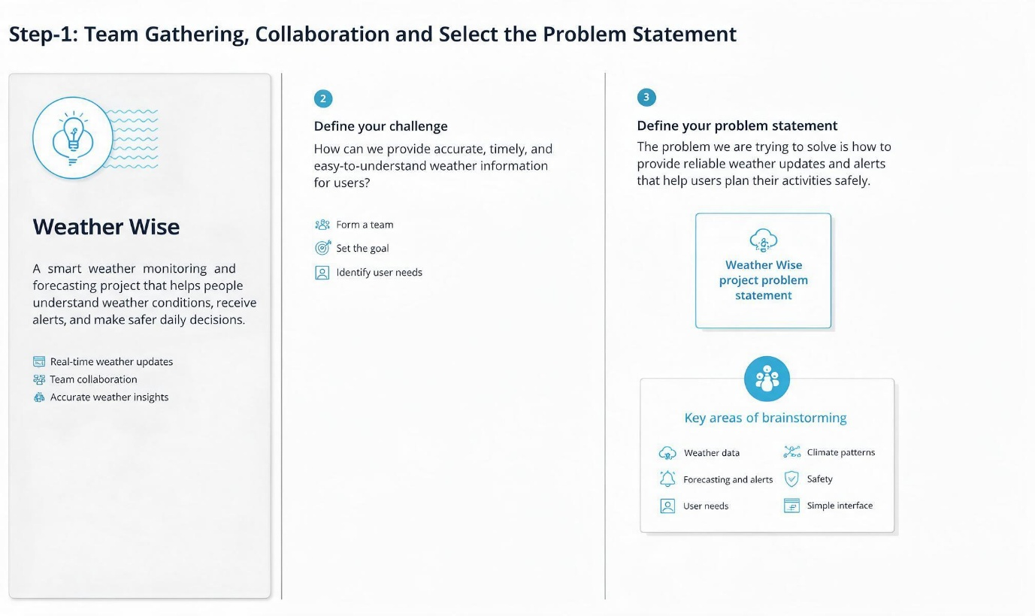
Step-2: Brainstorm, Idea Listing and Grouping:
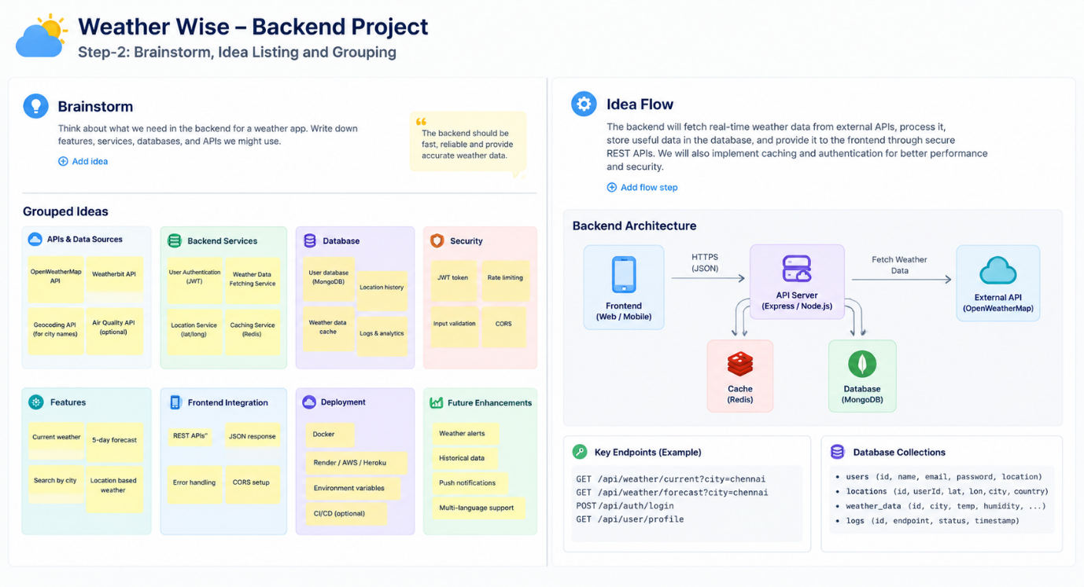
In this step, team members collaborated to brainstorm and list weather-related ideas using sticky notes:
- Displaying live temperature, humidity, wind speed, and UV index.
- Providing 24-hour hourly forecast graphs alongside a 7-day extended outlook.
- Air Quality Index (AQI) monitoring.
- A "Saved Locations" feature allowing users to bookmark and track favorite cities.
- Severe weather warning notifications and alerts.

Step-3: Idea Prioritization:
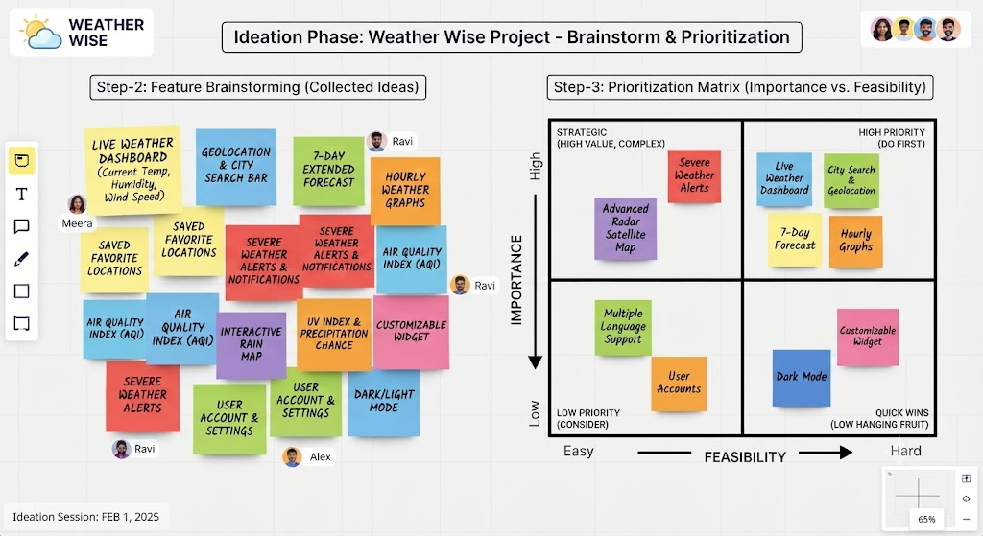Ideas were categorized and plotted on an Importance vs. Feasibility matrix:
- High Importance & High Feasibility (Do First):
  - Live Weather Dashboard
  - City Search & Geolocation feature
  - 7-Day Extended Forecast view.
(These features are crucial and straightforward to implement during the initial phase).
- Medium/Low Feasibility (Future Scope):
  - Advanced real-time radar satellite mapping.

